HOSANNA

SUPPORT

GROUP
  - ANNUAL REPORT 2019 / CHARITY NO. 1120997
A POSITIVE FUTURE
2019 has been a year of transition for the charity and we are very pleased to confirm that we will continue supporting Anne and her team for the foreseeable future. Despite the distress and upheaval suffered when Hosanna Primary School was forced to close, her team remain totally committed to continuing their work supporting vulnerable young people of Kisenyi and have formally established themselves as Smile Children Ministries.
PRIDIE TIERNAN – CHAIR OF TRUSTEES
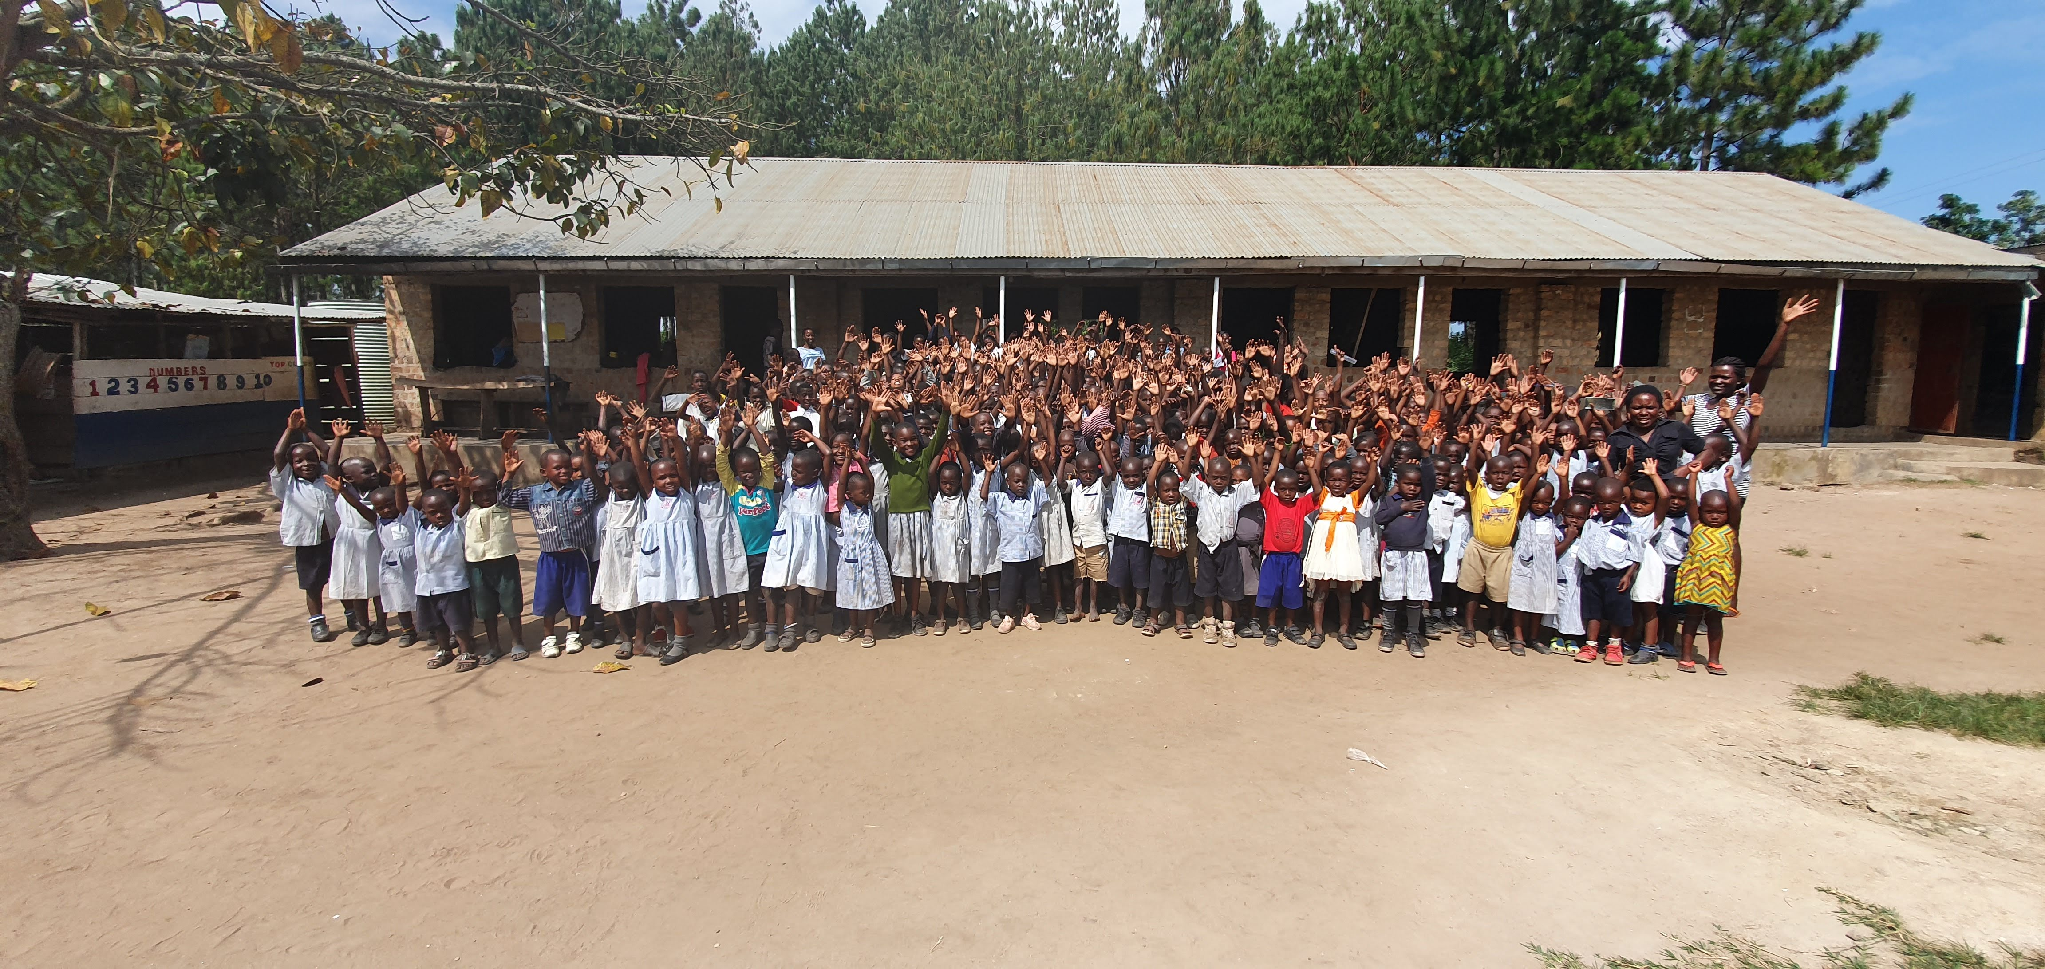
Childcare Primary School

AIM:
To advance the education and enhance the life opportunities of children in poverty in and around Kampala, Uganda – in particular, but not exclusively, by provision of financial support.

SUPPORTING SMILE CHILDREN MINISTRIES
Despite all the challenges faced in 2018, this year began very positively with Headteacher Anne Nsubuga, her daughters, Doreen and Cindie (both teachers), and her son Jesse, establishing and registering a new charitable group in Uganda called Smile Children Ministries. SCM’s aim is to ‘rekindle hope in mothers and children, and establish a self-sufficient and healthy community through education.’ The team continue to work with families in Kisenyi - with Anne and Doreen co-ordinating all sponsored children’s education between Eaglets Primary School, Childcare Primary School and secondary schools within the city, but the team are also working towards developing Childcare Primary School in Ndejje (where Cindie is the Headteacher) into a boarding school for children from Kisenyi. Their aim is to educate all sponsored primary age students at this school in the future, replicating the teaching and quality of care they so diligently practised at Hosanna School. SCM also intend to widen their remit in the future to champion healthcare for families as well as providing education and training for young people from other deprived communities.
“…rekindling hope in mothers and children, and establishing a self-sufficient and healthy community through education.”

NEWLY REGISTERED AS ‘HOSANNA SUPPORT GROUP’
Thanks to the support of our sponsors, this year the charity has been able to keep one hundred and twelve primary pupils, fifty-five secondary and two college students in education, as well as pay the salaries of valued teaching staff, provide medication for poorly members of the community and cover rent for the most vulnerable families.

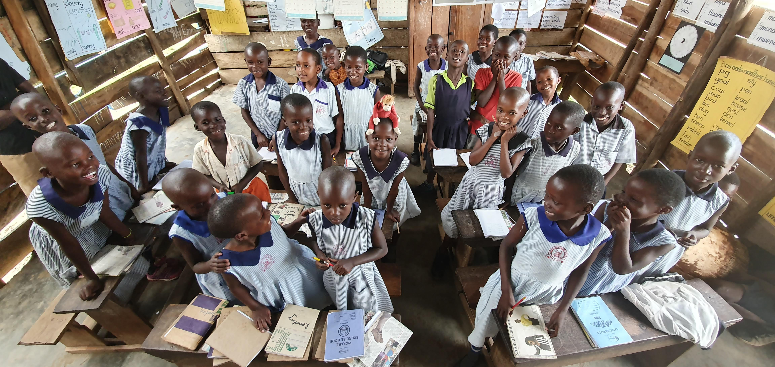
PRIMARY STUDENTS

Fifty five of our primary students are being educated at the team’s school site - Childcare Primary School, Ndejje. These children board. Our remaining fifty seven sponsored primary students are educated at Eaglets Primary School in Kisenyi, under the supervision of Teacher Doreen. The additional £10 per student donated for uniform and stationery was greatly appreciated.

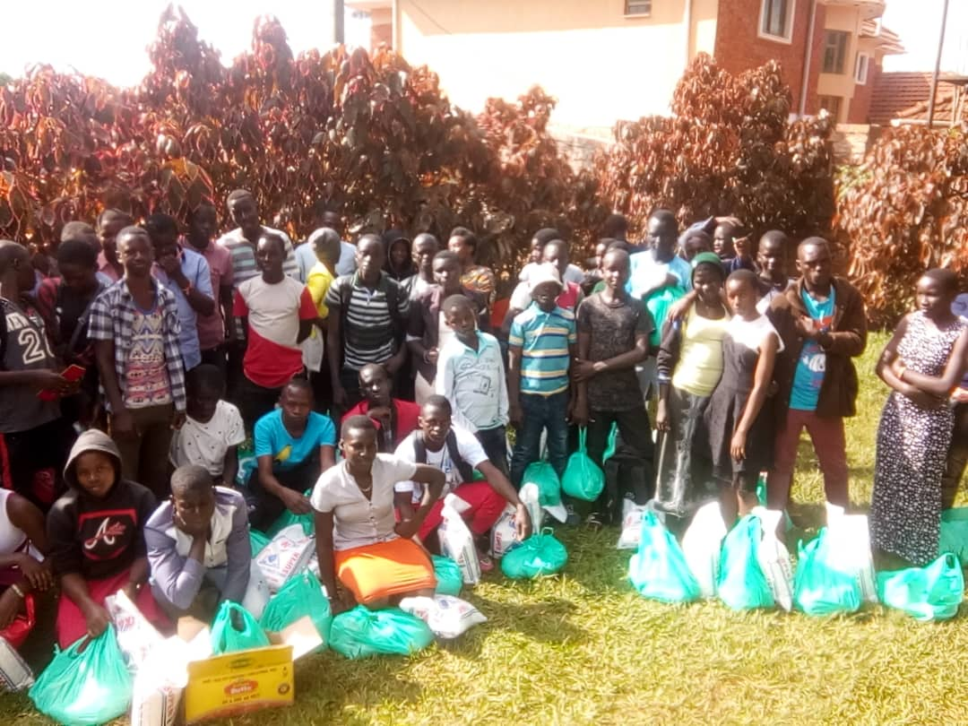
SECONDARY AND training STUDENTS
We have fifty five secondary students in education this year. Not all secondary students are sponsored at present but the Trustees are committed to enabling all existing sponsored students to complete their education and the charity has continued to support them. The secondary workshops run at the end of each term by Anne and her team, have continued to be a success. These workshops bring our older students together and provide encouragement, guidance and support for all our secondary students. The charity has also funded food bags for each of these youngsters containing basic food supplies for each of their families. Congratulations to Nabawanuka Betty who also finished her Business studies course in 2019!

BUNK BEDS
The charity was very kindly bequeathed £500 by a supporter in their will. The money has been used to buy much needed beds for the accommodation block at our primary school and will make an enormous difference to the many children who are currently staying on the school site for their education.
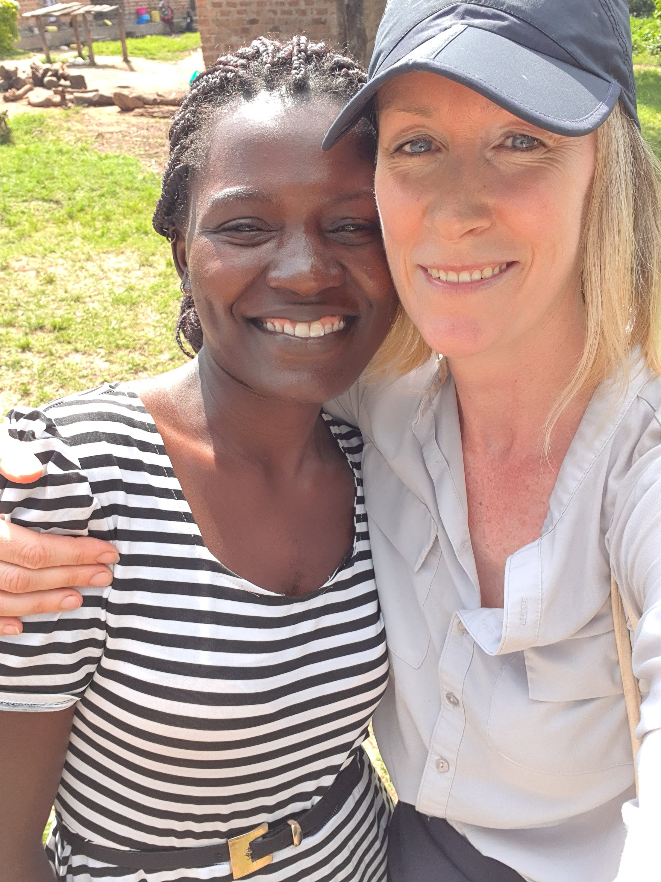
Headteacher Cindie Jones with Pridie Tiernan at Childcare Primary, Ndejje

VISIT TO UGANDA
In November 2019, Chair of Trustees Pridie Tiernan visited the Smile Children Ministries team in Uganda. Over those ten days, Pridie met all of the SCM Directors, visited both Eaglets and Childcare Primary Schools and families in Kisenyi, liaised with colleagues in-country about sustainable build projects (with the view to supporting the development of the Childcare site at Ndejje so that all of our students might be transferred to the school as residential boarders and complete their primary education under the SCM team specifically), and met with students to discuss their education and explore the option of business enterprise loans after finishing Senior Six. Her visit identified priorities for 2020 as meeting the cost of increased school fees, supporting with the provision of food for students, exploring the possibility of taking more primary students through to secondary school, finding a solution to the current water crisis at the Childcare Primary School site, and exploring how we might get UK businesses involved in the renovation and development of Childcare into a residential boarding school for all our primary students. Pridie’s full report, video footage and feedback was submitted to the Trustees and details about her visit are available on the webite at www.hosannasupportgroup.org.uk.
LATRINES
On Christmas Day, the latrines at Childcare Primary School collapsed. Supporters were quick to respond and funds were sent over to construct a replacement block in time for the start of the new year.
FINANCES
Due to this year being a transition period for the charity, apart from donations received for the latrines, no additional active fundraising was undertaken. The charity received £21,600 and transferred approximately £26,463.

LOOKING FORWARD
We look forward to exciting new developments in 2020, including the installation of water on site at Childcare Primary School and the development of the existing building into a fully residential boarding school for sponsored students and local children.
The Trustees would like everyone for their patience, love and support over the last couple of years and trust that many of you will be keen to carry on as things move forward in 2020.
With thanks and best wishes,
Pridie Tiernan (on behalf of the Trustees)

